1.I will show you how T3000 decode and encode
2.I will show the code of T3000 ,using C++.
1>>I advise you ,add a virtual device to debug the T3000 . It's easy to do it .
Switch to the offline mode

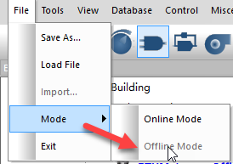
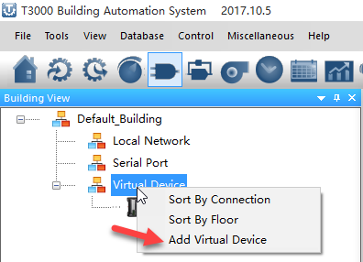
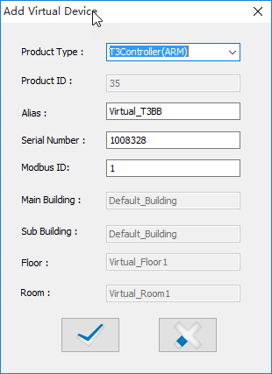

click the offline device
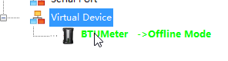
load a prog file to device
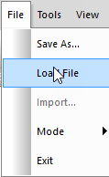
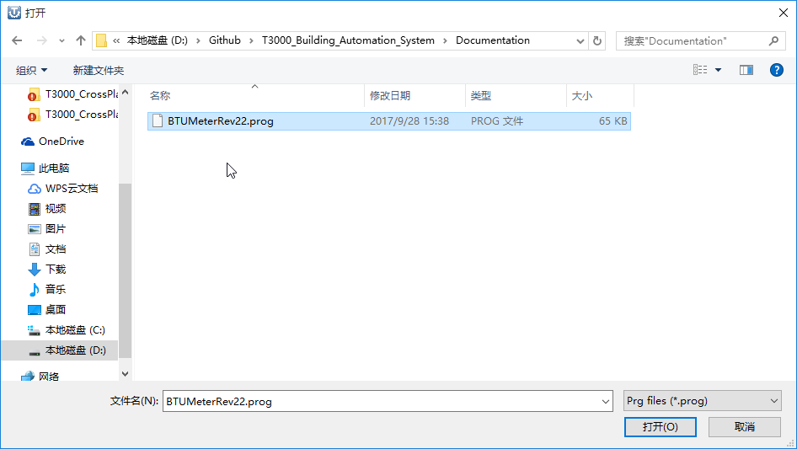

And then you can see some data in inputs,outputs,variables ,and program pages .
and i just show you program page.
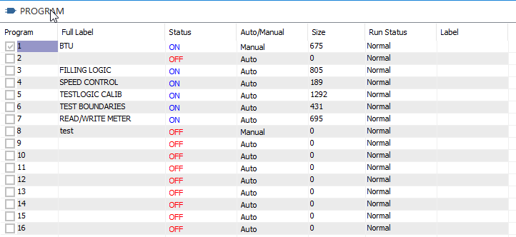
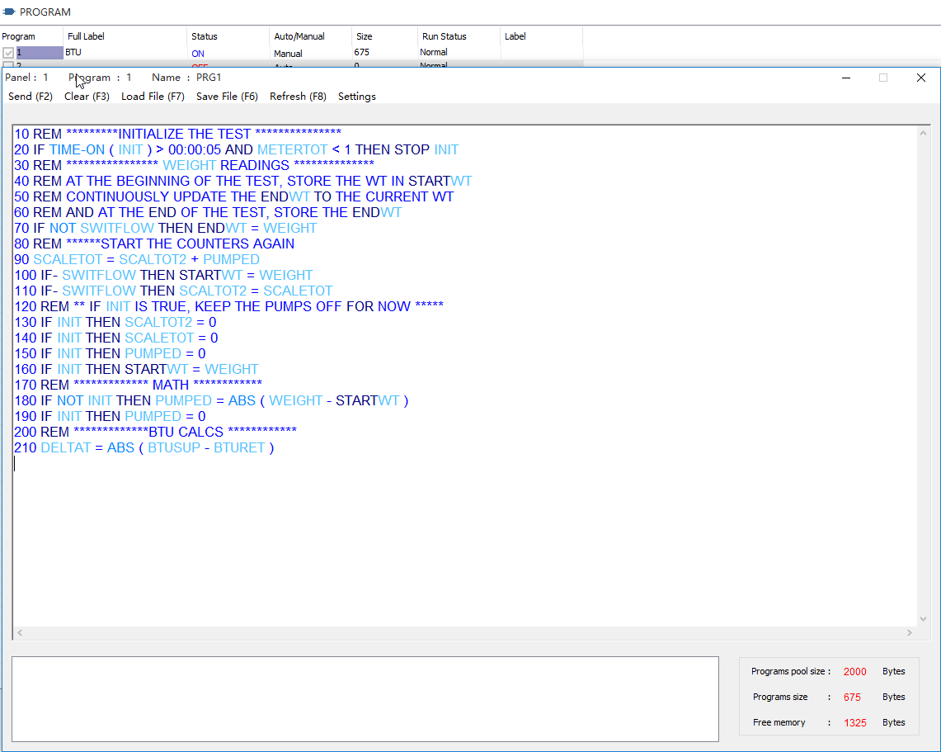

I think Maurice want to have a new editor for writing the code ,like vs' code editor.
If your editor is done ,i can merge your new editor into T3000. let them work together .

If you change the code ,and click F2 , T3000 will compile the code ,and then show some messages .
if the code have no errors ,it will be save into prog file.

BacnetProgramEdit.cpp
//Encode program code
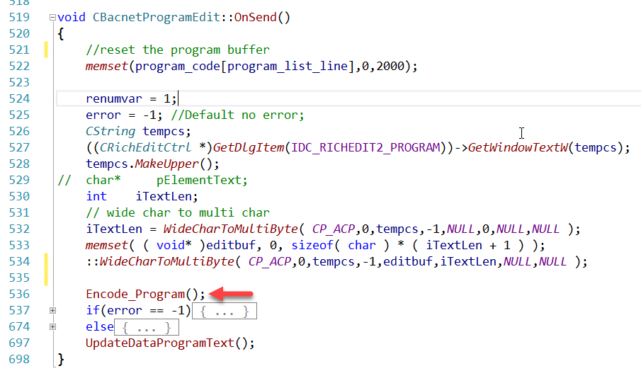
//decode the program code .
